React

Create a new React Application with the name “myfirstreact”, Run the application to print “welcome to the first session of React” as heading of that page.

Install node.js and npm

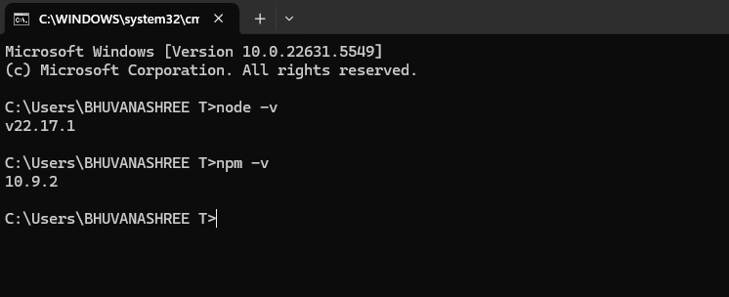

App.js

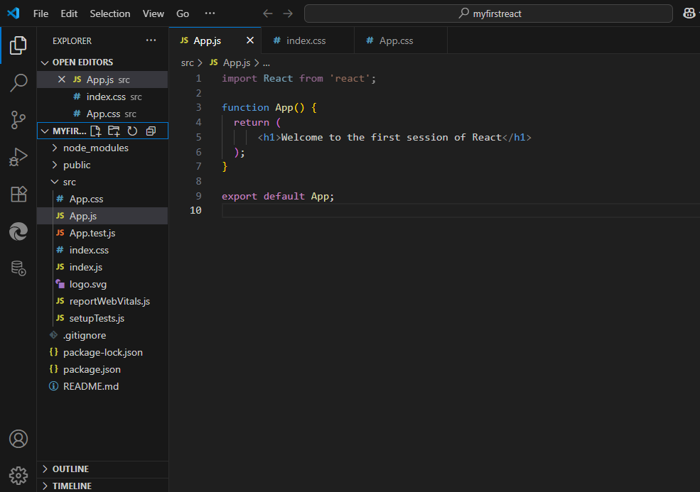

Run the npm start command to execute the React application

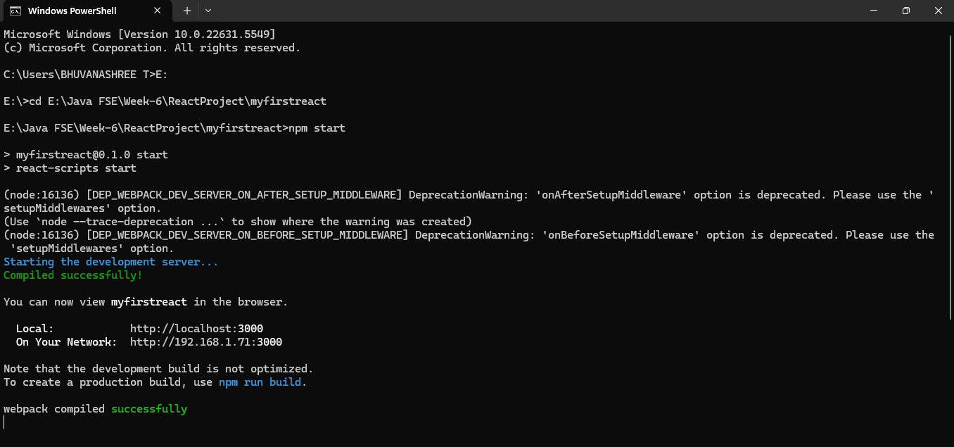

Open a new browser window and type “localhost:3000” in the address bar.

